ARTICLE ON : ARTIFICIAL INTELLIGENCE TECHNOLOGY IN EDUCATION

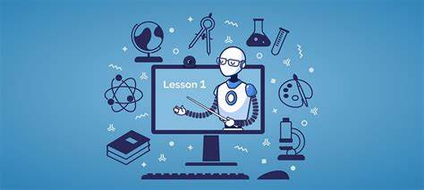

At its most basic level , AL is the process of using computers and machines to mimic humans perception , decision-making , and other processes to complete a task. Put differently , AI is when machines engage in high-level pattern-matching and learning in the processes.

Using of AI in education expand beyond student assessments and into other tools to support learning , often using built-in-stealth assessments that students do not even recognize as a test.

WORKING

1. TASK AUTOMATION : AI has been used in different industries to automate tasks , and it will come in handy way in the education sector. Teachers don’t teach , they also spend time grading tests , evaluating homework , etc., its lot of work involved. AI will automate these tasks to have more time to do their primary work of teaching without being bothered with administrative tasks.
2. PERSONALIZED LEARNING : AI can ensure that educational software is personalized for individuals. There are already adaptive learning software, games, and programs for students. This use of AI is probably one of its most significant in education as learning is more comfortable and smoother and cut across personal knowledge.

3.UNIVERSAL ACCESS : Educational classrooms can become globally available to all students through AI tools, even those that have hearing or visual impairment or speak different languages. With a PowerPoint plugin such as Presentation Translator, students have real-time subtitles for everything the teacher says. This opens up new possibilities for students who need to learn at different levels, who want to learn a subject unavailable in their school, or are sick and absent from schools. AI can break down the silos between traditional grade levels and schools.

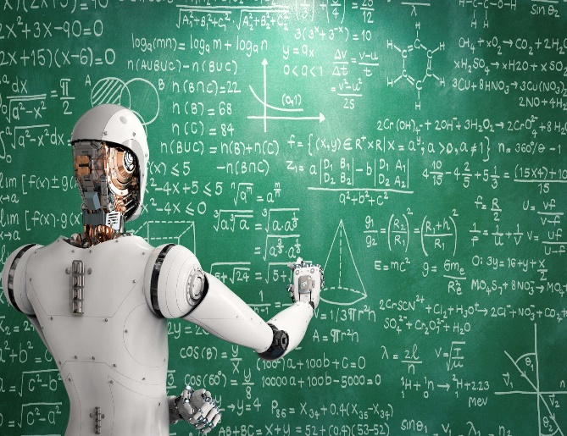

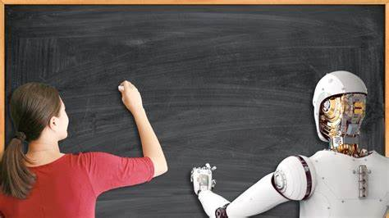

4. TEACHING THE TEACHER : One thing that is important in education is for the teacher to not rely on their old, residual knowledge. There are more facts that they need to know and teach the students as well. Not to mention the fact that they study and teach within a limited scope and there are many other things that they can still learn.

> With AI, teachers have comprehensive information available to them at their fingertips. This allows them to keep themselves educated in things that they didn’t know or improve on their past knowledge. With this, they will be better-rounded and have a more in-depth and broader knowledge base to sea with the 21st-century students.

5. TRIAL-AND-ERROR LEARNING LESS INTIMIDATING : Trial and error is a critical part of learning, but for many students, the idea of failing, or even not knowing the answer, is paralyzing. Some simply don’t like being put on the spot in front of their peers or authority figures like a teacher. An intelligent computer system, designed to help students to learn, is a much less daunting way to deal with trial and error.

6. 24/7 ASSISTANCE : It’s not just teachers that have access to a flurry of information through AI. Students do too. This means that they can get help on any topic at any time of the day with AI bots .Traditionally, students only get solutions to their problems when they meet with their teachers or professors and have the chance to ask them questions in the classroom. Thankfully, they will not have to wait that long anymore.

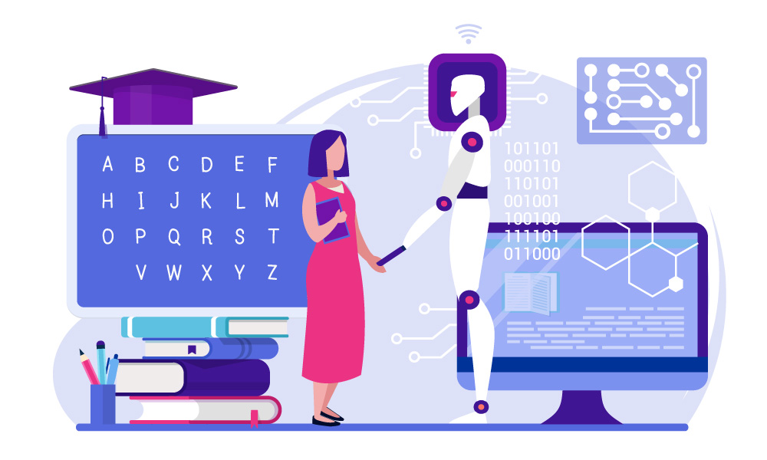

## Conclusion

Anyone who’s informed about global trends across different industries will know that personalization is top of the list. This is due to the advent of artificial intelligence, which is an advantage for the education sector. AI helps teachers up their game, providing them all the information that they need. It also allows teachers to create content that suits their students best while ensuring personalized learning. It automates tasks, so teachers have more time to do more teaching and impact the students better.